Tiny Toones Organization
www.tinytoones.org

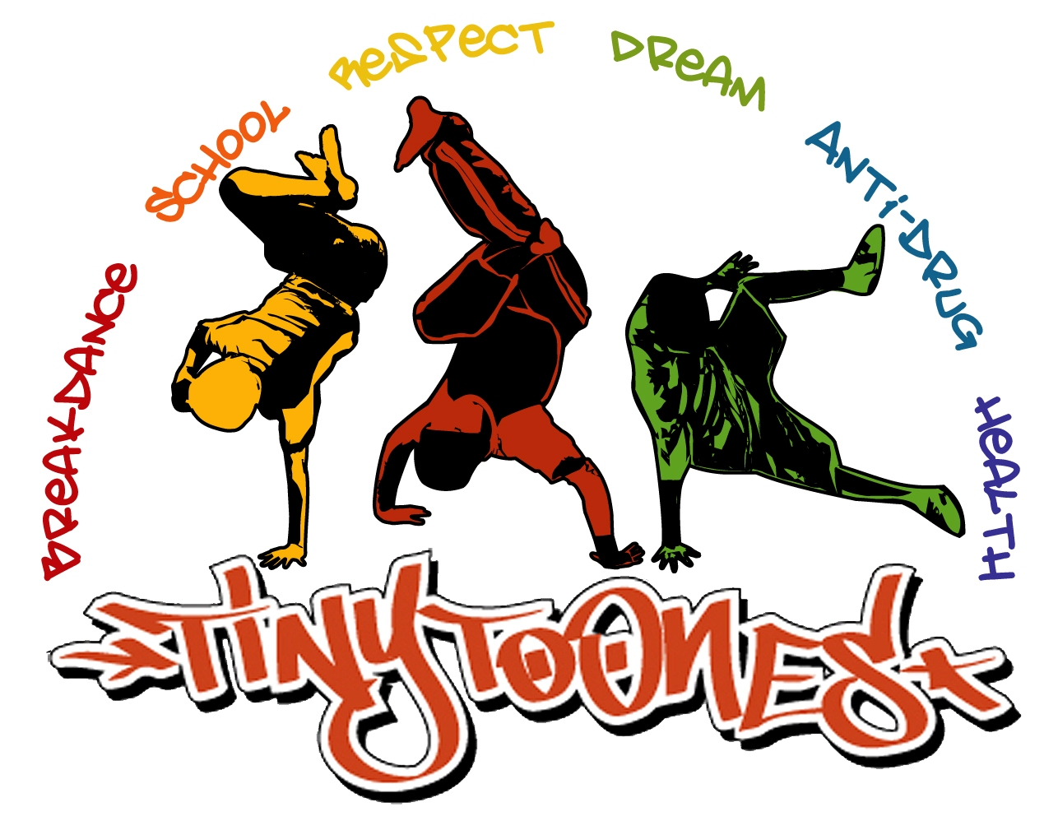

Tiny Toones
Volunteer Application Form

Application Instructions

Thank you for your interest in volunteering for Tiny Toones Cambodia. Please complete the application below for submission. All applications will be acknowledged upon receipt.

Applications will be reviewed and accepted dependent on skills required at the time . Notifications will be administered via e-mail.

Eligibility Requirements for Volunteers:
- Age 18+ before arriving in Cambodia
- Strong interest in social justice issues, education, the creative arts, community development and human rights.
- Ability to face challenges maturely
- Comfortable working with diverse groups of people
- Demonstrated interest in developing countries
- Done your homework about Tiny Toones. There is plenty of information on our website, facebook and youtube.

*Volunteers must find their own means to pay for all expenses including accommodation, transport, travel, food etc.
Tiny Toones Centre is based in Chba Ampov .

Upon receiving an invitation letter, potential participants must notify Tiny Toones Cambodia within 7 days of acceptance. Please review the requirements for consideration of Tiny Toones:

- A completed application form
- A recent photo
- Links to your work, including published articles, music, video, art.
- List the names, numbers and addresses of three people that have agreed to provide references for you
- Willingness to adhere to Tiny Toones Child Protection Policy
- E-mail application to short@tinytoones.org

Please note there is a $200 administration fee (if your application is accepted only).

Application Form for Tiny Toones

Personal Information

Last Name: ______________________ First Name: ________________________

Address: ______________________________________________________________________________
______________________________________________________________________________

Home Phone: _________________________ Personal Phone: ___________________________

E-mail: ______________________________________

Date of Birth: ____________________________ Age: _______ Sex: ________________

How long do you intend to volunteer? ______________
What months do you intend in volunteering in Cambodia? ___________________
What program are you most interested in being involved in? (please refer to website if not sure). ________________________________________________________________________

Highest education qualification received? _____________________________________________________________________________
_____________________________________________________________________________

Please describe past volunteer experiences

______________________________________________________________________________

Contact Information for three professional/character references:

Name Address Phone Number Relationship

1.

2.

3.

Language: _______________________________ Native Speaker: Yes No
Verbal Proficiency: Fair Good Excellent
Written Proficiency: Fair Good Excellent

Language: _______________________________ Native Speaker: Yes No
Verbal Proficiency: Fair Good Excellent
Written Proficiency: Fair Good Excellent

Please list your travel experiences in developing countries, including duration of time in those countries: ____________________________________________________________________________________________________________________________________________________________

How did you hear about Tiny Toones? (Please check all that apply)

___Television
___Radio
___Internet
___Newspaper
___Community
___Friend(s)
___Family
___Other (If so please note in the space below)

Select the issues you are interested in learning about while in Cambodia. Rank them from 1 to 10 (with 1 being the most important, and 10 the least important):

___human rights ___youth art
___poverty and economic development ___environment
___indigenous rights ___public health
___humanitarian and foreign aid ___democracy
___international law and politics ___education ___other (please specify)

Please answer all questions to the best of your ability, and limit responses to 5 sentences or less.

Please explain what most motivates you to volunteer for Tiny Toones.
____________________________________________________________________________________________________________________________________________________________________________________________________________________________________________________________________________________________________________________________________________________________________________________________________________________________________________________________________________________

What particular or unique skills do you have to share with Tiny Toones students? Are you qualified or do you have experience in these areas? eg: teaching english, creative arts.
______________________________________________________________________________________________________________________________________________________________________________________________________________________________________________________________________________________________________________________________________________________________________________________________________

List some of your recent personal achievements.
____________________________________________________________________________________________________________________________________________________________________________________________________________________________________________________________________________________________________________________________________________________________________________________________________________________________________________________________________________________

Describe your artistic talents, abilities, skills, and interests.
____________________________________________________________________________________________________________________________________________________________________________________________________________________________________________________________________________________________________________________________________________________________________________________________________________________________________________________________________________________

What are your personal expectations of working at Tiny Toones? What do you hope to learn from this experience?
____________________________________________________________________________________________________________________________________________________________________________________________________________________________________________________________________________________________________________________________________________________________________________________________________________________________________________________________________________________

What makes you unique and stand out from other potential volunteers?
____________________________________________________________________________________________________________________________________________________________________________________________________________________________________________________________________________________________________________________________________________________________________________________________________________________________________________________________________________________

How will you continue to support Tiny Toones once you have returned to your home community?
____________________________________________________________________________________________________________________________________________________________________________________________________________________________________________________________________________________________________________________________________________________________________________________________________________________________________________________________________________________

Please include anything else that you would like to share about yourself below:
____________________________________________________________________________________________________________________________________________________________________________________________________________________________________________________________________________________________________________________________________________________________________________________________________________________________________________________________________________________

